**Updating machine permissions for report display**

If you are getting load issues for custom reports or patient reports it’s a result of a folder permission issue. The IIS_IUSR and the Everyone user needs to be updated or added. Please update your machine’s folder permissions as follows:

**Update for IIS_IUSR**

1. Navigate to C:\Windows\ and find the Temp folder

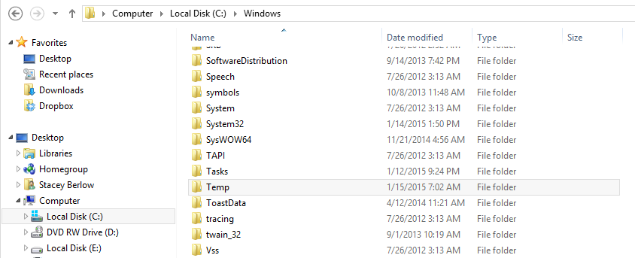

1. Right click on the Temp folder and select Properties
2. Unclick Ready only and then click on the Security tab

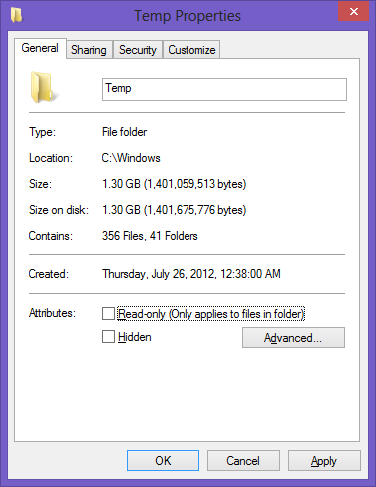

1. Find IIS_IUSRS and verify that this user has full control. If not, click on Edit

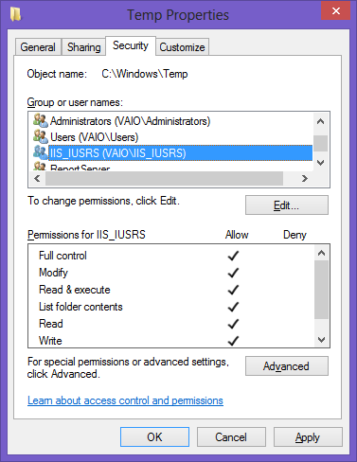

Click Edit if Full Control is not selected here.

1. Click Full Control check box to fill in all options. And click OK

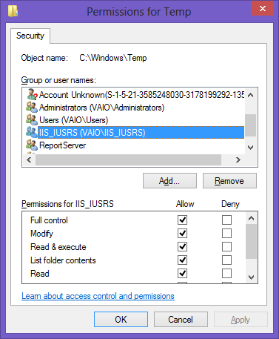

1. Click Apply

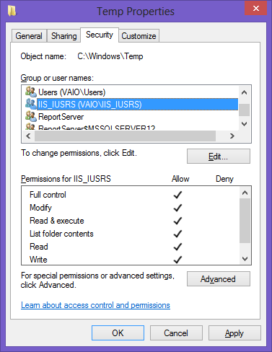

**Update for Everyone**

Check to see if you have the user “Everyone” in the list of users for the Windows/Temp folder. If the user Everyone is available, check that this user has full control enabled.

1. If Everyone is not in the list, click the Add button

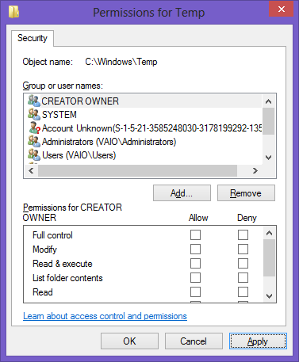

1. Enter “Everyone” in the object names box and click Check Names; click Advanced button.

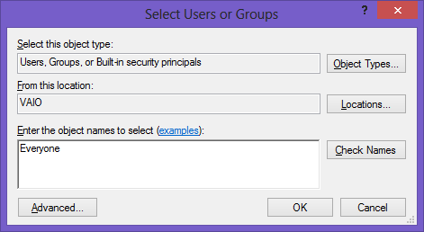

1. Highlight the Everyone user and set it to have full control.

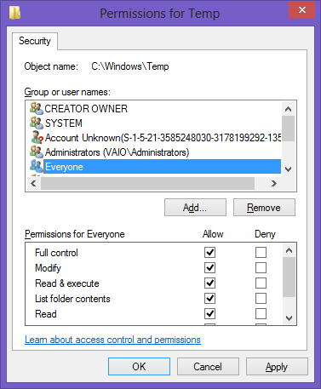

1. Click Apply to save the changes